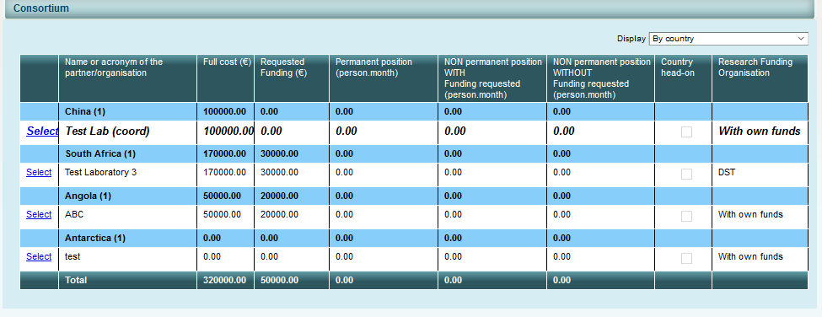
Due to the impossibility to fill this table online, please fill the table in a word and add the as a PDF as an annex with the title: “Acronym of the project – PM”
 | Organisation | Country | Person-month (PM)
Project Coordinator/Main Applicant
Project Partner 2
Project Partner 3
Project Partner 4
Project Partner 5
…

