www.leap-re.eu contact@leap-re.eu @leapRE_EU

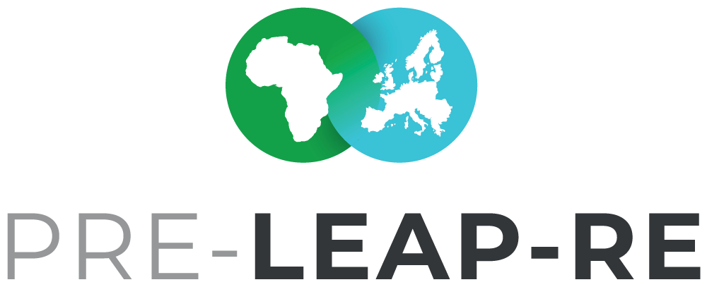Individual Funding & Contribution Regulations
BACKGROUND PAPER #4
Draft Version 3
21 May 2019

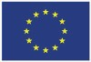

The Background Papers are documents in progress, which will form the basis for the discussion with committed stakeholders, who want to contribute to the joint programme LEAP-RE and who may want to become a consortium member or associated partner. Feedback and suggestions for these documents are welcome. The intention with the Background Papers is to foster an inclusive process as possible. The Background Paper series will be finalized in June/July 2019 after the PRE-LEAP-RE #2 Strategic Workshop from 24-26 June 2019 in Stellenbosch, South Africa.

The current Background Papers:

#1 BP Roadmaps & Ecosystem
Multi-Annual Roadmaps on Research &Innovation and Human & Institutional Capacity Building - Agendas & Pathways | Outcomes from the PRE-LEAP-RE Ecosystem Analysis

#2 BP Funding & Private Sector
Funding Concept | Private Sector Involvement | Open Philosophy & Intellectual Property Rights

#3 BP Long-Term Perspective
Theory of Change and Impact Pathways | Programme and Innovation Management Cycle
| Knowledge Management and Communication Framework | Monitoring & Evaluation Concept

#4 BP Individual Funding & Contribution Regulations
Individual (National) funding regulations will be collected and have to be applied supplementing the general agreed funding regulations of the consortium.

Co-coordinators for this Background Paper
Mr Fadel Traoré | Fadel.Traore@ANER.sn
Mr Stefan A. Haffner | Stefan.Haffner@DLR.de

Team of co-authors
AESG, Rwanda (Africa Energy Services Group Ltd.)
ANER, Sénégal (Agence Nationale pour les Energies Renouvable)
CEA, France (Commissariat à l'énergie atomique et aux énergies alternatives) DLR-PT, Germany (German Aerospace Center – Project Management Agency) DST, South Africa (Department of Science and Technology)
IE, Belgium (KIC Innoenergy SE)
JYU/UNIPID, Finland (University of Jyväskylä / UniPID)
LGI, France (LGI Consulting)
MESRS, Algeria (Ministry of Higher Education and Scientific Research)
POLIMI, Italy (Politecnico di Milano)
SU, Kenya (Strathmore University)

This project has received funding from the European Commission’s Horizon 2020 Research and Innovation Programme. The content in this presentation reflects only the author(s)’s views. The European Commission is not responsible for any use that may be made of the information it contains.

Content

- Pillar I | ‚External‘ Research Funding & Capacity Building | Open Calls for Proposals 3
- Pillar II | ‚Internal‘ Consortium R&I | Capacity Building | Infrastructures 4
- Glossary 5

Summary
In this background paper (BP), the templates for individual funding and contribution regulations of each contributor will have to be developed towards the LEAP-RE GA and CA.

Pillar I | ‚External‘ Research Funding & Capacity Building | Open Calls for
Proposals

Pillar I | ‚External‘ Research Funding & Capacity Building | Open Calls for Proposals
Name of Country | Name of Funding Party for open Calls for proposals
xxx
Who can apply?
xxx
What types of costs are eligible for funding?
xxx
Upper funding limits for the eligible costs per project
xxx
Additional requirements
xxx
For more information please contact the LEAP-RE country/institute information point
a) Institution
xxx
b) Contact person & data
Scientific contact: xxx
Administrative contact: xxx
c) Link(s) to website(s) with information and documents on national funding regulations, etc.
xxx

  - Pillar II | ‚Internal‘ Consortium R&I | Capacity Building | Infrastructures

Pillar II | ‚Internal‘ Consortium R&I | Capacity Building | Infrastructures
Access to Infrastructures
Description | Calculation in €
Organisation of events
Description | Calculation in €
Person Month
Description | Calculation in €
Other Contributions
Description | Calculation in €

  - Glossary

2iE | Fondation 2iE Association, Burkina Faso
ACU | Association of Commonwealth Universities, UK
AESG | Africa Energy Services Group Ltd., Rwanda
AMGA | Annotated Model Grant Agreement
ANER | Agence Nationale pur les Energies Renouvable, Sénégal
ANME | Agence Tunisienne de la Maitrise de l'Energie; Tunis
AU | African Union
BLE | German Federal Office for Agriculture and Food | Bundesanstalt für  Landwirtschaft und Ernährung
CA | Consortium Agreement
CCSE | Climate Change and Sustainable Energy
CEA | Commissariat à l'énergie atomique et aux énergies alternatives, France
CoI | Confirmation of Interest (of those who sent a letter of support before the GA)
CSIR | Council for Scientific and Industrial Research, South Africa
CSP | Concentrated Solar Plant
DEDEAT | Economic Development, Environmental Affairs and Tourism, South Africa
DLR | German Aerospace Center
DLR-PT | German Aerospace Center - Project Management Agency
DoA | Description of Action
DoW | Description of Work
DST | Department of Science and Technology, South Africa
ECCP | Electronic Content Collaboration Platform , PRE-LEAP-RE partners only
EERA | European Energy Research Alliance
EJP | European Joint Programming
EoI | Expression of Interest
EU | European Union
FCT | Fundação para a Ciência e a Tecnologia, Portugal
FNSSA | Food and Nutrition Security and Sustainable Agriculture
GA | Grant Agreement; also AMAGA
GC | Group of Contributors (Ministries, funding agencies, public and private research institutions and actors from the private sector like e.g.entrepreneurs)
HLPD | Hich Level Policy Dialogue
IE | KIC Innoenergy SE, Belgium
IPR | Intellectual Property Rights
JYU | Jyväskylä Yliopisto/University of Jyväskylä, Finland
KINNO | Knowledge & Innovation Consultanta Symvouleftiki Monoprosopi Epe, Greece
KMCF | Knowledge Management and Communication Framework
LEAP | Long-term Joint EU-AU Research and Innovation Partnership
LEAP-Agri | Long-term Joint EU-AU Research and Innovation Partnership on FNSSA (ERA-Net Cofund)
LEAP-RE | Long-term Joint EU-AU Research and Innovation Partnership on Renewable  Energy (RIA)
LGI | LGI Consulting, France
MESRS | Ministry of Higher Education and Scientific Research, Algeria
MI | Mission Innovation
NRF | National Research Foundation, South Africa
NWO | Netherlands Organisation for Scientific Research

OA | Open Access
PAUWES | Pan-African University of Water and Energy Services
PIMC | Programme and Innovation Management Cycle
POLIMI | Politecnico di Milano, Italy
PRE-LEAP-RE | PREparing for a Long-term Joint EU-AU Research and Innovation Partnership on Renewable Energy (CSA)
RD&D | Research, Development and Demonstration
RE | Renweable Energy
REA | Research Executive Agency under the power delegated by the EC
RES | Renewable Energy Sources
SG | Stakeholder Group
SOM | Senior Official Meeting
SU | Strathmore University, Kenya
WASCAL | West African Science Service Center on Climate Change and Adapted Land Use

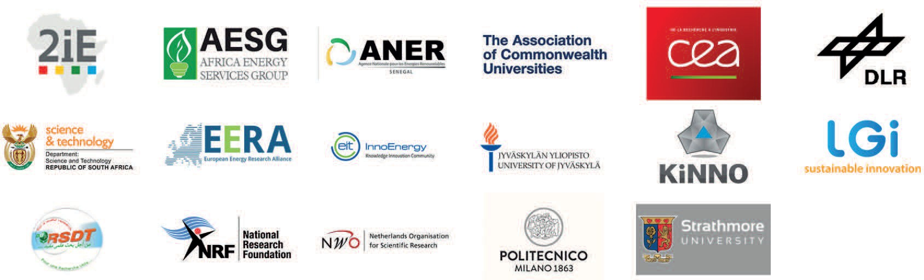

PROJECT PARTNERS

The PRE-LEAP-RE project has received funding from the European Union’s Horizon 2020 Research and Innovation Program under Grant Agreement 815264.

PRE-LEAP-RE © 2019

