www.leap-re.eu contact@leap-re.eu @leapRE_EU

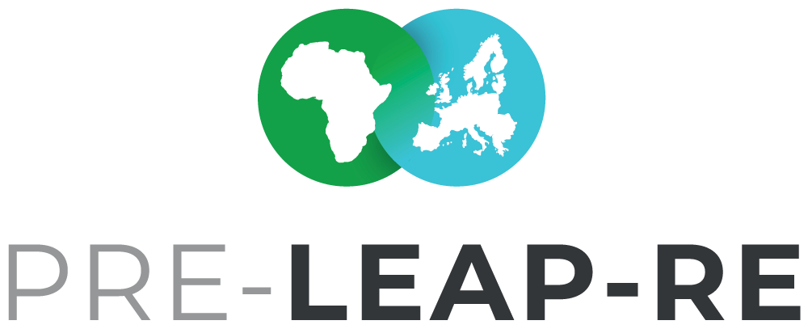Funding & Private Sector
BACKGROUND PAPER #2
Draft Version 17
22 May 2019

The Background Papers are documents in progress, which will form the basis for the discussion with committed stakeholders, who want to contribute to the joint programme LEAP-RE and who may want to become a consortium member or associated partner. Feedback and suggestions for these documents are welcome. The intention with the Background Papers is to foster an inclusive process as possible. The Background Paper series will be finalized in June/July 2019 after the PRE-LEAP-RE #2 Strategic Workshop from 24-26 June 2019 in Stellenbosch, South Africa.

The current Background Papers:

#1 BP Roadmaps & Ecosystem
Multi-Annual Roadmaps on Research &Innovation and Human & Institutional Capacity Building - Agendas & Pathways | Outcomes from the PRE-LEAP-RE Ecosystem Analysis

#2 BP Funding & Private Sector
Funding Concept | Private Sector Involvement | Open Philosophy & Intellectual Property Rights

#3 BP Long-Term Perspective
Theory of Change and Impact Pathways | Programme and Innovation Management Cycle
| Knowledge Management and Communication Framework | Monitoring & Evaluation Concept

#4 BP Individual Funding & Contribution Regulations
Individual (National) funding regulations will be collected and have to be applied supplementing the general agreed funding regulations of the consortium.

Co-coordinators for this Background Paper
Mr Fadel Traoré | Fadel.Traore@ANER.sn
Mr Stefan A. Haffner | Stefan.Haffner@DLR.de

Team of co-authors
AESG, Rwanda (Africa Energy Services Group Ltd.)
ANER, Sénégal (Agence Nationale pour les Energies Renouvable)
CEA, France (Commissariat à l'énergie atomique et aux énergies alternatives) DLR-PT, Germany (German Aerospace Center – Project Management Agency) DST, South Africa (Department of Science and Technology)
IE, Belgium (KIC Innoenergy SE)
JYU/UNIPID, Finland (University of Jyväskylä / UniPID)
LGI, France (LGI Consulting)
MESRS, Algeria (Ministry of Higher Education and Scientific Research)
POLIMI, Italy (Politecnico di Milano)
SU, Kenya (Strathmore University)

This project has received funding from the European Commission’s Horizon 2020 Research and Innovation Programme. The content in this presentation reflects only the author(s)’s views. The European Commission is not responsible for any use that may be made of the information it contains.

Content

Introduction 3
- Contributor’s Networks 3
- Open Calls and LEAP-RE Consortium activities 4
- One Coordination Secretariat and Call Secretariats 5
- Contributor’s Influence on Research Impact 6
- The Three Pillars Model and the Consortium Agreement for Budget Allocation 7
- Eligibility Criteria and Funding and Contribution Regulations 10
- Distribution of Funds for Open Calls for Research Proposals and other Activities 10 Funding Pots - Experience from the ERA Learn Platform 11 Pillar II - Selected Co-funded Research at 50% 11 Venture capital for R&I could rise interest 12

Stakeholders Involvement – the Quadruple Helix Approach 12
- Open Philosophy and Intellectual Property Rights 14
- Associated Partners 14
- Glossary 16

Summary
In this background paper (BP), several aspects of funding in the joint programme LEAP-RE are addressed. It describes the role of the contributors’ network, different options for research activities in the frame of LEAP- RE, the potential roles of a Coordination Secretariat (CoSe) and a Call Secretariat (CS), the contributors’ influence on research impact, the role and options of a consortium agreement, the distribution of funds in calls for research proposals and recommendations and discussion points for the development of LEAP-RE regarding the funding and budget allocation to be discussed and developed during the PRE-LEAP-RE workshops and round tables. Furthermore the private sector involvement will be addressed as well as Intellectual Property Rights (IRP) and Open Philosophy for managing and communicating knowledge.

Introduction
This background paper (BP) supplements the series of background papers and addresses funding of activities in the future joint programme LEAP-RE and thereafter. This first draft is based on the experiences of the ERA-Net ERAfrica, the ERAfrica Initiative, the ERA-Net Cofund LEAP-Agri and the EJP Rare Diseases and the discussions of the 1st PRE-LEAP-RE strategic workshop in December 2018 in Brussels. Moreover, the draft benefit of the revision of the Horizon 2020 Work Programme by the EU Commission approved in June 2019 which foresee the incoming of a RIA for the forthcoming
LEAP-RE WILL BE A NETWORK OF:
- Funding Institutions providing the financial support to execute dedicated actions
- Research Performing organisations contributing to the activities and to the sharing of the eligible cost
- Other actors within the Quadruple Helix approach in the field of RE like private sector or civil society organizations (or foundations and philanthropic organisations) may be engaged with a role that will be defined with dedicated negotiation
African- European joint programme on renewable energies which is supposed to follow the current CSA. LEAP-RE, as a joint programme, could adopt some of the preexisting experience and make leverage on the RIA instrument to complement them, suggest changes and add further elements as needed. It is intended to identify a group of funding institutions belonging to different typologies, who may become the core consortium for the future LEAP-RE and develop the design of #2 BP towards the writing of the proposal for LEAP-RE, which will be based on the PRE-LEAP-RE’s BPs system.

Contributor’s Networks
LEAP-RE will become both a (future) Horizon 2020-funded project supporting collaboration between Africa and Europe in the field of renewable energies (RE), and also a long-term network of stakeholders¹ all able to achieve the ambitious objective of the programme by contributing to its implementation in different ways and the maintenance of common activities after LEAP-RE.
The Multi-stakeholder group will be made by
    - Funding institutions that will participate in this bi-regional effort to support research, innovation, and capacity building activities in the field. This network may build on the members and achievements of the ERAfrica network of funders, who have undertaken cooperation in the ERAfrica² and LEAP-Agri³ projects and then attract other funders. The members consist mostly of governmental institutions from different countries from Africa and Europe who are investing in thematic fields of research & innovation (R&I) in general. Ministries responsible for the field of RE but also for education, economy and other thematically related areas to RE could be considered as funders. LEAP-RE will be developed by committed network partners. Funding institutions from the private sector are considered as consortium partners too.
    - Research performing organisations that will participate at the programme by sharing their experience and expertise and in carrying directly research and innovation projects and capacity building initiatives. The majority of this institutions may build on the network of EU-AU research institutions already engaged in the pre-existing long term partnership between Africa and Europe on renewable energies (among the many: AEEP, EUEI PDF, High Level Platform for Sustainable

1 See #3 BP ‚Long-Term Perspective‘
2 https://www.erafrica.eu/
3 http://www.leap-agri.com/

Energy Investment, an institutions, EU-Africa Long Term Partnership on Sustainable Energy: The Role of Research & Innovation)
    - Other institutions belonging to the Quadruple Helix approach for promoting innovation. Private sector or civil society organizations (like interest group representation, user and consumer protection organisations, and also foundations and philanthropic organisations) may be engaged as consortium partners contributing to the activities of the programme in particular as funders, or be it as associated partners (to be defined) and third parties.
Such a diverse set of participants supports the implementation of a wider set of activities and will not be relegated to the unique role of implementers. The needs and views of potential partners will be heard via dedicated dialogues undertaken within the project. The improvement of RE-systems by fostering innovations and innovation systems is a strategic element of the long-term implementation approach of LEAP-RE⁴ which at any rate, requires a strong commitment of public authorities because it implies strategy integration up to the highest level.
Particular attention should be paid to the inclusion of stakeholders from the private sector. Participation of the private sector in LEAP-RE activities (both internal and external to the consortium) is foreseen, as well as in the funding partnership as e.g. potential donors. Their willingness to invest in research is likely dependent on their accruing benefits from the research results. Engagement with the private sector should take place early enough in the development of the partnership to ensure their ability to participate in the shaping of the partnership.

Open Calls and LEAP-RE Consortium activities
The LEAP-RE consortium may include within the project activities two main types of actions: open calls for research proposals where third parties may be engaged, enlarging the network of researchers as beneficiaries on the one hand, and research and innovation and capacity building activities directly undertaken by the consortium members on the other hand.
Open calls should be jointly designed and implemented to support some of the research and other activities defined in the R&I and HICB roadmaps’ agendas described in the #1 BP ‘Roadmaps & Ecosystem’. The open calls should be competitive and open to participation from actors outside the consortium, on the basis of the criteria agreed by the participating funding parties. The calls should be funded with research funders’ budget of the consortium together with part of the
CALLS
- Open Calls: competitive calls open to participation from third parties. Funded by research funders’ budget along with the EC’s budget contribution.
- Consortium Activities: jointly executed and co- designed activities, implemented by LEAP-RE consortium members benefitting from 50% of the eligible costs.
European Commission’s (EC) budget contribution to LEAP-RE. The funding of the projects should be a balanced cooperation between African and European institutions. The participation options of researchers from countries who are not involved in the LEAP-RE consortium have to be clarified in detail and comply with the Annotated Model Grant Agreement (AMGA)⁵. Eligibility criteria could force to have e.g. at least 2 members of the LEAP-RE consortium involved in the proposal, one from Europe and one from Africa. This has to be discussed and agreed upon by the partners who will form the LEAP-RE consortium and draft the project. Common eligibility criteria for LEAP-RE will have to be also

4 Please have a look at the draft #3 Background Paper ‘Long-term perspective’ about the long-term approach for the network of partners (Theory of Change and Impact Pathway (TCIP), the Programme and Innovation Management Cycle (PIMC) and the AU-EU Knowledge Management and Communication Framework (KMCF)).
5 http://ec.europa.eu/research/participants/data/ref/h2020/grants_manual/amga/h2020-amga_en.pdf

defined by the LEAP-RE consortium. Together with additional individual (national) funding and contribution regulations to whom PRE-LEAP-RE consortium is dedicating a specific document (see #4 BP ‘Individual Funding & Contribution Regulations’).
Research & innovation and capacity building activities will be jointly designed and carried out by the LEAP-RE consortium members. These ‘internal consortium activities’, fully aligned with the R&I and HICB agendas and impact pathways, described in the #1 BP ‘Roadmaps & Ecosystem’, should be assigned based on competence and expertise of each member, by following a transparent and participative process, detailed in the Consortium Agreement (CA). These activities should be funded with research performing institutions’ contribution, together with part of the European Commission’s (EC) budget for LEAP-RE. The execution of these activities should be a balanced cooperation between AU and EU institutions. Research performing and other institutions participating should contribute to share at least the 50% of the direct eligible costs. It will be possible to engage external third parties, if their contribution is considered essential and the budget allocation is made in compliance with the GA. Aggregation of consortium members for the implementation of these activities will reflect equity among the EU and AU consortium members
The two points related to open calls and consortium activities will form the basis for R&I funding and partly for HICB funding too. A combination of both open calls and execution ‘internal’ LEAP-RE consortium activities is possible and foreseen.⁶

One Coordination Secretariat and Call Secretariats
The formation of one or more LEAP-RE secretariat(s) is one element of the LEAP-RE approach. The design of the secretariat(s) depends on the formats of research funding, like open calls or research by the consortium. This would be a decision
COORDINATION
- A Coordination Secretariat for managing the Network.
- A Call Secretariat for managing the calls, if not included in tasks of the Coordination Secretariat. A rotating secretariat could be envisaged.
to be made based on an agreement of the LEAP-RE consortium partners in particular by the funding agencies.
One Coordination Secretariat (CoSe) could be considered for managing and coordinating the LEAP-RE network (see the Draft Management and Implementation Concept). Furthermore, if it is not the role
of the CoSe to organise calls, specific Call Secretariat(s) (CS) could be considered for designing and implementing open calls for research proposals, depending on the investment level and geographical radius of funders.
For the long-term perspective after LEAP-RE, a rotating secretariat structure could be envisaged, with periodically changing responsibilities of African and European institutions in co-leadership.
The sustainable long-term funding of a CoSe and perhaps CS after LEAP-RE is an issue to be discussed and developed with the stakeholders. In LEAP-RE might be options for funding both secretariats, partly or even 100%. For the long-term, after the LEAP-RE programme, a sustainable structure like e.g. a membership fee for funding a sustainable secretariat infrastructure could be envisaged.
The total cost of the management of LEAP-RE will be financially supported by the EC. A potential scenario which includes 2 coordinator (full time, senior profile), 4 policy officers (2 senior and 2 junior including two of them as communication manager at 50%), 2 financial officer and 2 assistant (full time) might cost around € 5 Million. All positions should be represented by one African and one European colleague. The consortium will have to agree on the format and a balanced international selection of stuff members of the CoSE.

6 Please have a look at the draft #1 BP Roadmaps & Ecosystem.

For a long-term perspective and maintenance of a CoSe, models like the BELMONT Forum will be considered.
THE BELMONT FORUM MODEL
- Scientist and stakeholder support is made possible through Collaborative Research Actions (CRAs), which are the Forum equivalent of a call for proposals. New themes are developed through a scoping process and made available for proposals through the Belmont Forum website and its Grant Operations page.
- Each proposal submitted to a CRA theme in the Belmont Forum Grants Operations (BFgo) must consist of a project co-developed by natural scientists, social scientists, and stakeholders that hail from at least three countries.
- Stakeholder is used in its broadest sense in CRAs, representing the potential to co-develop and co-implement projects with communities, policymakers, business and industry, unionized bodies, tribal organizations, non-governmental organizations, and many others not listed here.
- The research itself can take place within one or more countries anywhere in the world, but the team itself must be eligible for support from three funding organizations participating in the CRA.
- Projects are merit reviewed and awards are made through coordinated funding from individual organizations and participants would receive support from their respective institutions.
- Not all Belmont Forum members participate in every CRA.

HTTP://WWW.BELMONTFORUM.ORG

Contributor’s Influence on Research Impact
One major objective of the future funding of R&I is to ensure a balanced collaboration in the research projects to be funded. A regional balance (equity in the participation from both African and European partners) is expected, as well as, given the same quality of the research, a balance in issues such as gender, career development (i.e. between early-career and established researchers), and age.
Particular attention will be paid to ethics, in accordance with the EC regulations, and criteria for LEAP-
RE funded activities. Other priorities may be identified through dialogue processes.
CALL REQUIREMENTS
- A balanced collaboration between African and European partners.
- Attention to issues such as gender, career development, and age.
The implementation of such priorities should be included in the eligibility requirements of the calls as an addition to the core criteria of scientific excellence.
Eligibility requirements could require a
balance in the researchers and other individuals implementing the project, but also in the kind of structure requested, for example, by utilizing for selecting among the equally valuable researches, an inclusive, gender-oriented or youth-oriented approach.
LEAP-RE will monitor and evaluate its own outputs, together with external support⁷. The evaluations should be conducted by both African and European partners in close collaboration. All the activities will be monitored and evaluated by using an M&E framework developed specifically for LEAP-RE internal activities, jointly agreed by the consortium members and aligned with the most common and accepted international framework in terms of research and innovation in the field of renewable

7 Please see #3 BP Long-Term Perspective

energies. In particular, the contribution of LEAP-RE to SDG7 will be taken into consideration with deep care. Particular attention should be paid to communicating research outputs, particularly to end- users and policy makers, for better research uptake. LEAP-RE as a whole will be monitored and evaluated too.⁸
Joint activities and open calls with the AU Research Grants, Belmont Forum, or other relevant initiatives could be considered sooner or later.
The involvement of relevant stakeholders in the design of LEAP-RE’s Theory of Change and Impact Pathway (TCIP)⁹ is fundamental. While considering the needs of external stakeholders, like end-users, entrepreneurs and decision makers, the consortium members will be able to focus their activities much more effectively and efficiently towards a desired impact.

The Three Pillars Model and the Consortium Agreement for Budget Allocation
The Grant Agreement (GA) will contain binding statements from the consortium on their own contribution to the LEAP-RE project, including both funding for open calls, sharing the total eligible costs for internal activities, and in-kind contributions even by third parties. In figure 1 ‘Draft LEAP-RE Calculation’ these are steps 1 to 3
THREE HYPOTHETICAL SCENARIOS TO EXPLAIN THE CALCULATION OF THE EC TOP-UP PRINCIPLE:
Scenario A: The consortium invests 15 Million €, the EC will contribute 15 Million €, so that ½ of LEAP-RE’s budget will be from the EC. The total budget of LEAP- RE would be in this case 30 Million €. The EC will invest their max. possible investment.
Scenario B: The consortium invests 30 Million € and
the EC will contribute only 15 Million €, because this is
their threshold. The EC will not invest further 30
Million € in this Scenario B.
Scenario C: The consortium invests 10 Million €, the EC will contribute 10 Million € Top-Up which is 50% of the whole budget of LEAP-RE. In this case the EC will be below their theoretical max. option of investing up to 15 Million € as Top-Up.
… other scenarios are possible too and will be calculated together with the group of contributors (GC).
– 1^{st,} an official cost calculation, 2nd, the binding contribution commitment of the consortium partners and 3rd, the development of a Consortium Agreement (CA). Step 1 and 2 will be an iterative process which would be defined based on the overall funding and contributions and the negotiation with all the consortium members: the funding agencies and contributing institutions and the executors of the internal activities.
The allocation of the available budget and the use of the EC Top-Up will be outlined in the CA. The available budget consists of the total contributions by the consortium
partners to the eligible costs together with the grant contribution by the EC – the EC Top-Up. The EC’s Top-Up is calculated based on the consortium’s contribution with a specific funding quota. The threshold for the EC Top-Up is a max. of 50% of the total eligible costs (direct and indirect) of the
project’s budget and limited to a max. of 15 Million €. In the context of the dialogue of the funders, PRE-LEAP-RE will moderate the development of a calculation scenario.
Once the consortium signs the GA and the EC’s Top-Up has been calculated, the LEAP-RE partners are free to decide on the allocation of the EC’s Top-Up. Given the information included in the GA. Preliminary discussion with the EC and detailed reasoning within the consortium members, the consortium is oriented to support a three pillar approach as displayed in the figures below.

8 Please have a look with this regards at the draft #3 BP ‘Long-term perspective’ about the LEAP-Coordination-Approach for the network of partners, including research uptake approaches.
9 For more information on the Theory of Change and Impact Pathways (TCIP), please refer to the draft #3 BP ‘Long-term perspective’.

External research funding in open calls could be managed in pillar 1; internal research executed by the LEAP-RE consortium member in pillar 2; and in pillar 3, the management and coordination of the LEAP- RE and capacity building measures. Furthermore, capacity building activities could be also integrated in the first two pillars.
In this three pillar’s scenario, a calculation will be made about the total eligible costs of each pillar and each consortium member’s own financial contribution. The contribution to the total eligible cost will come from the consortium members (i.e. research performing institutions and funding institutions) and the 50% EC’s contribution allocated amongst the pillars.
In the CA, the consortium partners will agree on the allocation of their contribution to the total eligible costs. The share of budget among the three pillars will be agreed and defined, while securing that all management costs will be covered by own and EC’s contribution. Management costs could also be covered partly as in-kind contribution to allow for a larger budget allocation to the other pillars.
The development of the CA will be an internal negotiation process of the consortium, independently from the EC.

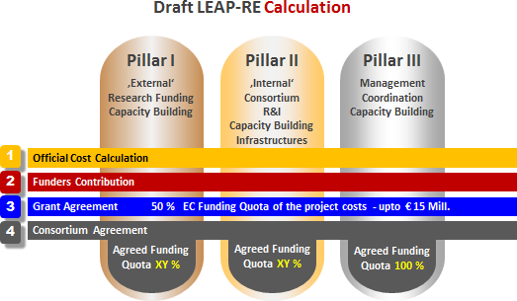

Figure 1: Draft LEAP-RE Calculation

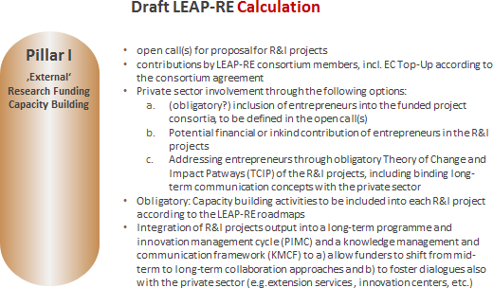

Figure 2: Draft Pillar I LEAP-RE

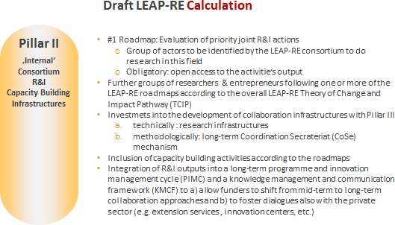

Figure 3: Draft Pillar II LEAP-RE

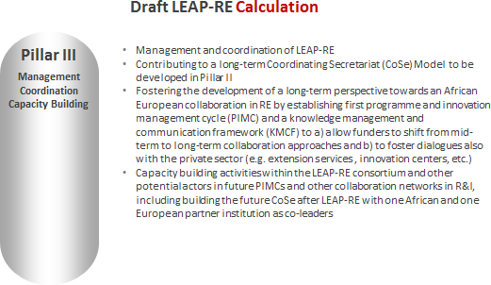

Figure 4: Draft Pillar III LEAP-RE

  - Eligibility Criteria and Funding and Contribution Regulations
Depending on the agreements of the group of funders, common eligibility criteria and funding and contribution regulations will have to be
CALL REQUIREMENTS
- The group of funders jointly defines common eligibility requirements and Individual national funding regulations will also be applied for the open call
- In order to carry out the internal activities, LEAP-RE criteria will also be defined by the consortium members. Compliance with the GA will be also guaranteed
defined by the consortium members for each pillar. These common funding and contribution regulations will be complemented by (national) eligibility criteria and funding and contribution regulations.
For the open call (pillar I - see paragraph Distribution of Funds for Open Calls for Research Proposals and other Activities ), in the (national) eligibility criteria and funding and contribution regulations, the
contributors will define, who can apply to the call, what type of costs are eligible for funding, upper funding limits for the eligible costs per project, any additional requirements and contact data of information points and link(s) to website(s) with information and documents on eligibility criteria and funding regulations.
For the internal activities and the management of the project (Pillar II and Pillar III – see paragraph 10), the consortium may also define internal criteria for enforcing the AU-EU sharing of responsibility and joint research, the inclusion of young research and gender equity.

Distribution of Funds for Open Calls for Research Proposals and other Activities

Ministries, public funding agencies, public and private research institutions and other actors from the private sector are already or could be interested in contributing their resources in LEAP-RE activities. With the LEAP-RE RIA, the inclusion of the investments of also research institutions and private players will make a difference in the collaboration in R&I and HICB from the past, and make a further step towards a closer bi-continental collaboration in RE.
Public funding institutions can contribute to the PRE-LEAP-RE in different ways. In the open call in Pillar I, according to their national regulations, they can support national researchers and innovators in a transnational collaboration environment. They could also contribute to the activities in Pillar II which are of common interest and e.g. in building a long-term infrastructure and mechanism for maintaining the collaborative network.
Research institutions and private players might not only being interested in developing projects and applying for funds in the open call in Pillar I. They might be interested in the activities within Pillar II as R&I or capacity building activities could be funded at 50%. There might also be an interest, according to some specific internal regulation, to contribute to Pillar I as funders. For the Research institutions that will not be partner, there might be the option to participate to the open calls as implementing agencies.
Engagement and co-investment with private sector in general could be beneficial for identifying need- oriented R&I priorities and addresses earliest stages of innovation. Their engagement can be in Pillar II and, for some of them who wish to fund third parties research or capacity building activities, even Pillar I.
The effectiveness of the whole LEAP-RE project and projects funded by LEAP-RE, would be improved by also raising the chances of commercial success while including private sector actors.
For meeting the needs and requirements of the private sector, its actors should be involved in formulating the Multi-Annual Roadmaps, which should support the strategy and planning of technology development by aligning innovation targets with knowledge and resource requirements.

Funding Pots - Experience from the ERA Learn Platform
The ERA Learn Platform highlighted three potential options that could be used for distribution of funds in particular in a joint call management¹⁰:
- A virtual common pot: participating national funders distributing funding directly to their own national / regional applicants;
- A real common pot: participating national funders provide their financial contribution to a central unit, which then distributes funding to project consortia;
- A mixed funding pot: part of the call budget is spent as a virtual common pot, and part with a real common pot.
These options should be considered by the Consortium, and a selection made for each of the pillars’ budgets in the project. It seems to be likely that the LEAP-RE consortium will agree on a mixed funding pot.

Pillar II - Selected Co-funded Research at 50%
This is the most common funding mode for co-funded research projects by research performing institutions and private players. All participating organizations will contribute to the eligible total cost of an agreed specific action. The PRE-LEAP-RE consortium may decide to share joint effort for research and capacity building in order to encourage more joint AU-EU actions.
This funding mode enables experienced research institutions and private players with experience in

10 Source: https://www.era-learn.eu/support-for-p2ps/implementing-joint-calls/funding-of-projects/distribution-and- monitoring-of-funds

R&I and capacity building to invest and participate in the RIA.
The consortium may decide to define a threshold of minimum commitment for the research institutions and private players to become partners in the RIA in order to avoid a huge and un- manageable consortium. The threshold could be defined on an annual base i.e € 100.000, which makes a total of € 500.000 in 5 years in LEAP-RE.
Each research institution and private player will have to commit their contribution in the GA as well as in the CA together with the envisaged research and capacity building activities. With the signature in the GA and the CA the contributors will give a legally binding commitment.
With the EU-Top UP, administrative measures like financial accounting and reporting needs could be covered.
One activity the stakeholders may wish to invest in could be the development of principles, mechanism as a guideline and infrastructure for future CoSEs, from which all actors will benefit after LEAP-RE.

Venture capital for R&I could rise interest
The development of revolving funds for R&I on different geographical levels could be considered as an option too. This would mean the establishment of a fund addressing the need of researchers and innovators for venture capital. This venture capital will have to be re-transferred to the fund at a later stage. This could create on the long run a constant loop for innovation funding. This fund could be managed on the long run by the CoSE.

Stakeholders Involvement – the Quadruple Helix Approach
The opportunity for designing and deploying an integrated R&I framework for RE in developing economies shall be driven by key factors such as population and economic growth, energy demand growth and a growing share of clean power targets in the regional energy mix. The latter reflects a need to secure on energy security and improve economics relative to fossil fuels costs in some regions.
Additionally, RE is now widely recognised as one of the most economical ways of addressing climate change and many countries have established energy efficiency targets. Energy is critical to solving the climate change challenge and is also the fuel powering our economies and the society. Transportation, industry and households consume energy in the form of electricity or fuel, produced from different renewable and fossil fuel sources and delivered through an array of infrastructures built and operated by many actors. Over the past decade, technology innovation and a favorable policy environment have transformed the energy landscape but effort still needs to be put.
Funding in R&I activities in RE falls short of what is required to effectively accelerate innovation, and large investments in breakthrough technologies for sustainable energy innovation comes with risks that are greater than what countries or the private sector can undertake. Thus, an international and independently managed scheme that manages R&I funding from interested countries, as well as from the private sector, could potentially have significant impact if well designed and supported by a critical mass of stakeholders.
The Quadruple Helix plays role in Research and Innovation as it is nowadays more and more envisaged. This approach was also a mainstay of the PRE-LEAP-RE project proposal and the benefit for each stakeholder are included in table 1. For this reason, as already highlighted in paragraph 2
‘Contributor’s Networks’ and taking profit of the RIA scheme, research performing institutions and private players will be contributing partners within the LEAP-RE consortium.
This approach is in line with that is requested to enable an inclusive innovation eco-system.
Indeed, an effective innovation ecosystem therefore enables entrepreneurs, companies, universities, research institutions, investors and government agencies to interact effectively to maximise the

economic impact and potential of their research and innovation.
Thinking about the innovation ecosystem in this way suggests some important features that lie at the heart of why and how the innovation ecosystem is a useful focus:
An ecosystem is …
- dynamic and flexible, allowing new entrants to become part of the ecosystem with minimal entry barriers while allowing parts of the ecosystem to fade and leave active involvement.
- an open system with no respect for jurisdictional boundaries or geographies.
- not concerned with its structures but is rather focused on the range and quality of interactions within and between the structures in the ecosystem.
Several systems and networks have been created for deployment of the use of RE, especially with the active participation of the private sector. These are mainly networking and promotion platforms for attracting inbound venture and private equity funding for RE start-up companies. These clusters could prove an important channel for private finance because of the involvement of many of the biggest industrial companies. The role of these technology networks could change, however since climate mitigation and adaptation problems, especially in infrastructure and utilities, require solutions to whole systems rather than individual problems. These clusters could provide an important component in scaling up mitigation solutions. Private sector companies that are directly linked to project development and knowledge management and communication of projects with an RE agenda, could be an important part of any future solution, with a potential that is largely unexploited to date.

Academia | Public Sector | Private Players | Civil Society
- Financial and technological conditions to achieve and promote innovative ideas on the market  - Obtaining the copyrights – remuneration for the developed and patented use, popularity amongst business and scientific circles  - High certification training and graduating specialists with practical and theoretical knowledge application.  - Developing a laboratory scientific basis with high-end equipment  - University and students’ involvement in innovative businesses.  - Accelerating innovative economic development  - Preventing ”brain exodus”  - Increasing foreign investments and possibilities for exports  - New high-end tech jobs | - Accelerating innovative economic development  - Preventing ”brain exodus”  - Increasing foreign investments and possibilities for exports  - New high-end tech jobs  - Increase standard living level  - Consolidating the staff component in the technical and scientific potential of the region  - Attracting investments; improving infrastructure | - For high-end technology companies:  - Development of new technological solutions and creating new competitive products  - Reducing the innovative cycle and implementing the idea into the product  - Reducing the risk of creating and manufacturing non- competitive products  - Attracting competitive specialist to promote intensive scientific products  - For investments and risk funds  - Availability of implemented innovative projects ready to be promoted on the market  - Availability of innovative projects in an incomplete implementation phase  - Innovative  development ”bank”;  Profitable | - Consumer protection  - End-user interest forward  - Cross-cutting fields advocacy (environment, employment, gender- balance, development cooperation, sustainable land use, etc.)  - “Innovation ecosystem model for commercialization of  research results”, Proceedings of the International Conference on Business Excellence, 11(1), 1020-  1032.

- Increase standard living level  - Consolidating the staff component in the technical and scientific potential of the region  - Attracting investments; improving  infrastructure. |  | developments fields

Table 1: Benefits for the Stakeholders

Sustainable energy innovation Eco-Systems: A case Study
Sustainable energy innovation can better be deployed through networks and systems that cross national borders and involve a multitude of actors, from large companies and start-ups to research and policy institutions. Such an initiative is Mission Innovation (MI), an alliance launched at COP21 comprising 22 governments and the EU, representing 80% of global clean energy RD&D and 70% of global GDP. MI members have committed to double their clean energy RD&D spending per year by 2021 and to work to make sustainable energy more widely affordable and scalable. MI focuses on seven specific technology areas and cross-cutting issues to accelerate innovation.

Open Philosophy and Intellectual Property Rights
The financing mechanism expected for the LEAP RE (including European Union funding through its H2020 program) would require that each beneficiary comply with the EU rules dedicated to Open Access (OA) and Intellectual Property Rights (IPR). Under Horizon 2020, the legal basis for open access is established in the framework program and its rules for participation. These principles are reflected in specific requirements in the AMGA and the Horizon 2020 work programs. The AMGA provides specific explanations on the Grant Agreement.
Rules on OA and IPR from African side will have to be considered in LEAP-RE too and will become a part of the GA and the CA.
LEAP-RE will adopt the principle that publicly funded research data is a public good, produced in the public interest, which should be made openly available with as few restrictions as possible in a timely and responsible manner that does not harm IPR and privacy of informants.
Additionally, LEAP RE partners could define in the CA further commitments that will be considered necessary to take into account supplementary concerns in regard to above mentioned documents.

Associated Partners
The bigger a project consortium will become the more difficult it will be to coordinate the processes. Therefore it is of the interest of LEAP-RE to keep the consortium of the project as small as possible. That’s why an agreement has to be defined on how to include associated partners who will not be part of the management and coordination processes of the project but e.g. of the funder’s network which contributes to the eligible costs of the project.
In case it would be an EC’s obligation, that the funds, which will have to form the basis for the
calculation of the EC’s contribution to the project, have to be provided only from consortium partners, then the consortium will have to be formed by all contributors. Ideally, LEAP-RE would find a solution together with the EC, that the budget contributions from ‘associated partners’ could be included into the calculation of the eligible costs of the project and hereby of the EC’s Top-up.

Another category of ‘associated partners’ could be defined for those, who are not contributing to the eligible costs of the project, but wish to be linked to the LEAP-process in the context of the project and thereafter. Defining the roles of those associated partners might be considered also in the context of the development of the CoSE and the long-term perspective for LEAP-RE (PIMC and KMCF) with basic network mechanisms.

Glossary

2iE | Fondation 2iE Association, Burkina Faso
ACU | Association of Commonwealth Universities, UK
AESG | Africa Energy Services Group Ltd., Rwanda
AMGA | Annotated Model Grant Agreement
ANER | Agence Nationale pur les Energies Renouvable, Sénégal
ANME | Agence Tunisienne de la Maitrise de l'Energie; Tunis
AU | African Union
BLE | German Federal Office for Agriculture and Food | Bundesanstalt für  Landwirtschaft und Ernährung
CA | Consortium Agreement
CCSE | Climate Change and Sustainable Energy
CEA | Commissariat à l'énergie atomique et aux énergies alternatives, France
CoI | Confirmation of Interest (of those who sent a letter of support before the GA)
CSIR | Council for Scientific and Industrial Research, South Africa
CSP | Concentrated Solar Plant
DEDEAT | Economic Development, Environmental Affairs and Tourism, South Africa
DLR | German Aerospace Center
DLR-PT | German Aerospace Center - Project Management Agency
DoA | Description of Action
DoW | Description of Work
DST | Department of Science and Technology, South Africa
ECCP | Electronic Content Collaboration Platform , PRE-LEAP-RE partners only
EERA | European Energy Research Alliance
EJP | European Joint Programming
EoI | Expression of Interest
EU | European Union
FCT | Fundação para a Ciência e a Tecnologia, Portugal
FNSSA | Food and Nutrition Security and Sustainable Agriculture
GA | Grant Agreement; also AMAGA
GC | Group of Contributors (Ministries, funding agencies, public and private research institutions and actors from the private sector like e.g.entrepreneurs)
HLPD | Hich Level Policy Dialogue
IE | KIC Innoenergy SE, Belgium
IPR | Intellectual Property Rights
JYU | Jyväskylä Yliopisto/University of Jyväskylä, Finland
KINNO | Knowledge & Innovation Consultanta Symvouleftiki Monoprosopi Epe, Greece
KMCF | Knowledge Management and Communication Framework
LEAP | Long-term Joint EU-AU Research and Innovation Partnership
LEAP-Agri | Long-term Joint EU-AU Research and Innovation Partnership on FNSSA (ERA-Net Cofund)
LEAP-RE | Long-term Joint EU-AU Research and Innovation Partnership on Renewable  Energy (RIA)
LGI | LGI Consulting, France
MESRS | Ministry of Higher Education and Scientific Research, Algeria
MI | Mission Innovation
NRF | National Research Foundation, South Africa
NWO | Netherlands Organisation for Scientific Research

OA | Open Access
PAUWES | Pan-African University of Water and Energy Services
PIMC | Programme and Innovation Management Cycle
POLIMI | Politecnico di Milano, Italy
PRE-LEAP-RE | PREparing for a Long-term Joint EU-AU Research and Innovation Partnership on Renewable Energy (CSA)
RD&D | Research, Development and Demonstration
RE | Renweable Energy
REA | Research Executive Agency under the power delegated by the EC
RES | Renewable Energy Sources
SG | Stakeholder Group
SOM | Senior Official Meeting
SU | Strathmore University, Kenya
WASCAL | West African Science Service Center on Climate Change and Adapted Land Use

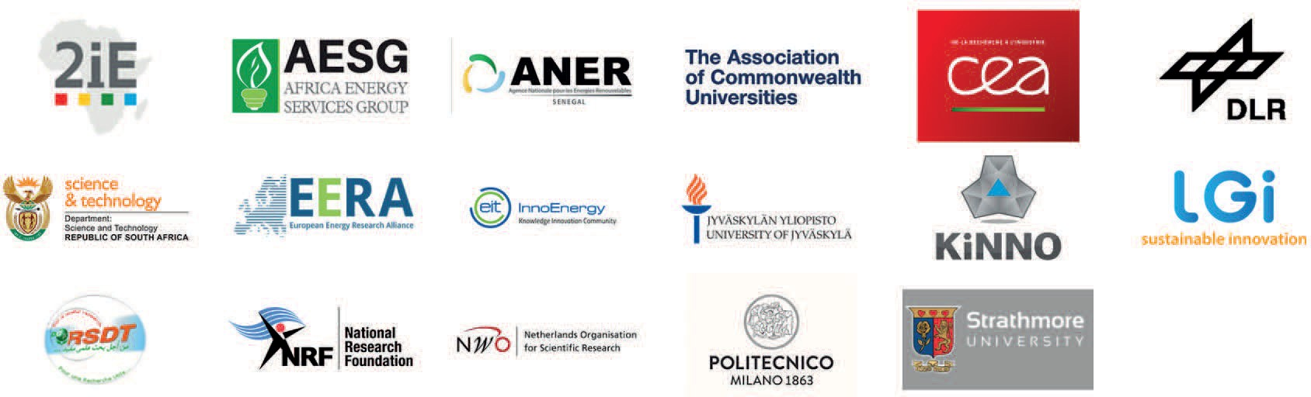

PROJECT PARTNERS

The PRE-LEAP-RE project has received funding from the European Union’s Horizon 2020 Research and Innovation Program under Grant Agreement 815264.

PRE-LEAP-RE © 2019

